# Supplementary Information

## Models

In this section, we describe each of the input models used for metamodeling, their conversion to probabilistic surrogate models, and their coupling. For each of the input models, we distinguish the free parameters, the input variables, and the output variables. All models were implemented in either Matlab or Python (tested on Matlab version R2020b, Python version 3.7.6 installd using Conda version 4.9.2). All surrogate models were implemented in Python (tested using the same version). The code for all models, surrogate models, and coupled surrogate models is provided in a designated Github repository (<https://github.cs.huji.ac.il/ravehb-lab/immune-synapse-metamodeling>), in subfolders InputModels, SurrogateModels, and CoupledModels, respectively.

### Model 1

**Input and output.** Model 1 computes the spatiotemporal patterning of a population of TCR and CD45 molecules embedded in the plasma membrane of T-cell during T-cell activation. The input to the model includes the model parameters and the initial configuration of the T-cell plasma membrane, the TCR and CD45 molecules on the T cell membrane, and the peptide-MHC (pMHC) complexes on the APC membrane (Table 1). The output of the model is the spatiotemporal trajectory of the model’s configuration, as follows.

**Model configuration.** A model configuration $c$ is defined as follows (Fig. S1). A section of the T-cell membrane at the IS is represented by a grid of nxn squares of axa nm. Each TCR or CD45 molecule occupies a single grid square, without overlap. In addition, each TCR and CD45 molecule has a certain vertical length hTCR and hCD45. A section of the APC membrane facing the T-cell membrane at the IS is represented by a two-dimensional grid of identical dimensions. Each pMHC complex occupies a single grid point of the APC membrane. Finally, the T-cell and APC membranes can be both curved; the distance of the T-cell membrane from the APC at each grid square is specified by ${Δz}_{i,j}$. In all simulations, the TCR and CD45 molecules were initially located in circular clusters (fig. S1. C), based on {DOI: 10.1038/s41467-018-03127-w}, although in principle, this is not a requirement of the model.

**Model interactions:** We assume local equilibrium, and thus, the interactions in the model are described using a Hamiltonian $H_{}$ over a model configuration $c$:

$$H(c)=H_{membrane}(c)+H_{compression,CD45 }(c)+H_{compression,TCR }(c)+H_{bind }(c).$$

$H_{membrane}$ is the total bending energy of the T-cell and APC membranes due to changes in ${Δz}_{i,j}$, $H_{compression,CD45 }$ and $H_{compression,TCR }$ are the spring energies associated with compressing the vertical length of the CD45 and TCR molecules, respectively, and $H_{bind }$ is the binding energy of a molecule to a molecule on the opposite membrane.

$H_{i,j membrane}=\frac{κ}{2a^{2}}(4{Δz}_{i,j}-({Δz}_{i+1,j}+{Δz}_{i-1,j}+{Δz}_{i,j+1}+{Δz}_{i,j-1}))$.

$a^{2}$ is the area of one square, $κ$ is the membrane bending rigidity.

$$H_{compression, CD45}=\frac{k}{2}{(h_{CD45}-h_{0,CD45})}^{2}, if{ h}_{CD45}<h_{0,CD45}, otherwise H_{compression, CD45}=0.$$

and

$H_{compression, TCR}=\frac{k}{2}{(h_{TCR}-h_{0,TCR})}^{2}, if h_{TCR}<h_{0,TCR} , otherwise{ H}_{compression, TCR}=0.$

$k$ is the spring constant of the molecule.

$H_{bind,CD45}=u_{bind,CD45 }, if {Δz}_{i,j} is in the molecule binding range$.

$H_{bind,TCR}=u_{bind,TCR-pMHC }, if TCR and pMHC are in the same square$.

Planar molecules interactions:The planar interactions of the molecules is implemented in the property that two molecules on the same membrane can not be at the same square at the same time (interacting like hard spheres). TCR molecules can have a self-clustering factor, Pon, that ...

Vertical molecules interactions: Receptor-ligand interactions occur when a TCR and a peptide-MHC have the same planar location. In this case they are forced to be bound and at that location the inter-membranes distance, Δz, will be 13 nm. Molecule-membrane interactions: CD45 molecules interact with the APC membrane as repulsive springs when Δz < CD45 resting length.

**Model dynamics.** We evaluate the model dynamics using Reaction-diffusion Markov-Chain Monte-Carlo {DOI: [10.1039/B902017A](https://www.researchgate.net/deref/http%3A%2F%2Fdx.doi.org%2F10.1039%2FB902017A), DOI:[10.1093/BIOMET/57.1.97](https://doi.org/10.1093/BIOMET%2F57.1.97)}.A typical simulation runs for 10,000 iterations. To simulate Brownian diffusion of each molecule along the membrane, we sample a random molecular step $r$ in a random direction (uniformly sampled between $0$ and $2π$ radians), and with a magnitude that is the absolute value of a normally distributed scalar with mean 0.0 and standard-deviation ; *D* is the diffusion coefficient in units of ${nm}^{2}{⋅s}^{-1}$. Therefore we can treat the propagation of the simulation as propagation in time with time step = $Δt$. We used periodic boundary conditions (molecules that exit at one side enter on the other side). At every iteration, all the TCR and CD45 molecules are moved to a new location with random step $r$; the move is accepted/rejected using the Metropolis criterion: it is accepted with $P_{accept}=1$. if the energy at the new state $H_{new}$ is lower than the energy at the old state $H_{old}$. If the energy at the new state is higher, the attempt is accepted with $P_{accept}=e^{-\left|ΔH\right|/kT}, where ΔH=H_{new}-H_{old}$. In addition, the inter-membranes distance ${Δz}_{i,j}$ at every grid square is changed by a normally-distributed random step $dz$ with mean = 0 nm and standard deviation = 1 nm.

Dynamics rules for one iteration: Molecules dynamics: (we are using periodic boundary conditions - if a molecule exists the simulation array it enters on the opposite side): Attempting to move all TCR and CD45 molecules simultaneously to new locations. If a molecule attempts to move into a new square that was occupied in the previous iteration it is rejected. If more than one molecule attempts to move into the same new square all these attempts are rejected. The molecules that were accepted by criterions 1.2 and 1.3 change their height, h, to the new $Δz_{i,j}$ at their new locations and are accepted or rejected according to the Metropolis criterion for molecules.

Membrane dynamics: All square attempt to move up or down to a new $Δz_{i,j}$. The $Δz_{i,j}$ of square i,j that is occupied by a TCR and a pMHC is forced to have $Δz =h_{0,TCR}$. The rest of the new $Δz_{i,j}$ are accepted or rejected according to the Metropolis criterion for membranes.

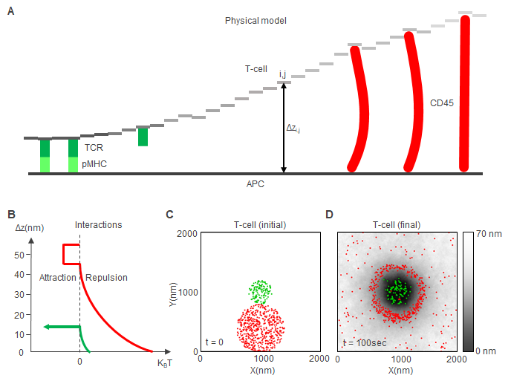

**Fig. S1. A. side view of the simulation setup.** B. Interaction potentials: The inter-membranes distance, where a TCR and a pMHC are in the same square, will be fixed at Δz = 13nm. CD45 acts as spring with a spring constant of 0.1 kT/nm2 and resting length of 50nm. C. initial conditions of the simulations. NTCR ~ 125, NCD45 ~ 500, The inter-membranes distance, Δz = 70nm (white color) except at the locations of the molecules, where for the CD45 locations Δz = 50nm (resting length of CD45 molecule) and for the TCR locations Δz = 13nm (length of bound αCD3-TCR). pMHC molecules (not shown here) are uniformly scattered over the APC membrane with surface density of 300/μm2. D. molecules distribution and topography after 10,000 iterations (100 sec). The colorbar represents inter-membranes distance.

Table 1: Free parameters of Model 1

|  |  |  |  |  |
| --- | --- | --- | --- | --- |
| **Name** | **Description** | **Default value** | **Units** | **References** |
| Array size | size width x size length. | 2000x2000 | $$nm$$ | - |
| a | Area unit that divides the array to square units that has approximately the lateral size of a molecule. | 10 | $$nm$$ | WL,  InterCells |
| Δt | Iteration length. | 0.01 | $$sec$$ | InterCells |
| Niter | Number of iterations | 10,000 | - | InterCells |
| h0,TCR | Vertical resting length of the TCR. | 13 | $$nm$$ | WL |
| h0,CD45 | Vertical resting length of the CD45. | 50 | $$nm$$ | WL |
| NTCR | Total number of TCR molecules. | ~125 | $$-$$ | - |
| NCD45 | Total number of CD45 molecules. | ~500 | $$-$$ | - |
| DTCR | Diffusion coefficient of TCR molecules. | 10,000 | $$nm^{2}/sec$$ | WL |
| DCD45 | Diffusion coefficient of CD45 molecules. | 11,000 | $$nm^{2}/sec$$ | WL |
| κ (kappa) | Membrane rigidity. | 25 | $$kT⋅nm^{2}$$ | WL |
| k | Spring constant | 10 κ/a2 |  | WL |
| uCD45 | Binding energy of CD45 to APC membrane | -10 | $$kT$$ |  |
| uTCR | Binding energy of TCR to APC membrane | -10 | $$kT$$ |  |
| uTCR-pMHC | Binding energy of TCR to pMHC | Effectively -inf | $$kT$$ |  |
| Pon,TCR | Probability of self clustering of TCR when in contact with another TCR | 0.995 | $$sec{}^{-1}$$ | InterCells |
| Input parameters (initial configuration): | | | | |
| TCR initial distribution | Circle with uniformly distributed molecules. | Center = (1000,1000)  R = 200 | $$nm$$ | - |
| CD45 initial distribution | Circle with uniformly distributed molecules. | Center = (1000,400)  R = 400 |  | - |
| Δz0 | Initial membrane height. It is constant everywhere except at the locations of the molecules. | 70 | $$nm$$ | InterCells |
| Δz0,TCR | Initial membrane height at the locations of TCR molecules. | h0,TCR |  | InterCells |
| Δz0,CD45 | Initial membrane height at the locations of CD45 molecules. | h0,CD45 |  | InterCells |

#### 

#### Surrogate model:

To learn a surrogate model for Model 1, we first mapped its outputs for different input parameter values (Fig. S2A-C); we created a probabilistic graphical model {REF} that describes statistical relations among its variables in parameterized form (Fig. S3; Table S1A,B); next, we fitted the probabilistic graphical model to recapitulate the statistical relations between the model parameters and its values. We now explain each of these steps in detail.

**Parameter phasespace mapping:** We evaluated the model using 20 different values of membrane rigidity, κ, from κ=5 kT/nm2 to κ=100 kT/nm2 at 5 kT/nm2 intervals, using an identical initial configuration each time (Fig. S1F). As reported earlier [(Neve-Oz et al. 2018)](https://paperpile.com/c/CRnYld/H6vM), and as expected from the Kinetic Segregation model {DOI: 10.1038/s41467-018-03127-w}, on which Model 1 is based, the CD45 and TCR molecules formed concentric outer and inner rings, respectively, with a low-density depletion zone separating between the two rings (Fig. S1G); this result holds regardless of the precise choice of model parameters or the initial configuration of the TCR and CD45 molecules. Therefore, we analyzed the following three properties at 10 different simulation time points for different input parameters: the width of the ring of TCR molecules $w_{TCR}^{KS}$ (Fig. S2A), the width of the ring of CD45 molecules $w_{CD45}^{KS}$ (S2B), and the width of a low-density depletion zone that typically emerges between the TCR and the CD45 rings (Fig. S2C). The width was computed using pair-correlation analysis, as explained below {REF Intercells 2018, Razvag; else?}.

**Surrogate probabilistic graphical model.** We created a probabilistic graphical model, specifically a Bayesian network {Friedman, Koller} describing statistical relations among the membrane rigidity parameter κ, the time *t*, and the widths of the TCR and CD45 rings and the depletion zone between them.

Based on the output heatmaps we create a surrogate model for each. In the surrogate model we made an approximation of an output heatmap by using a two dimensional surface z(t,κ) that is a function of random variables (RV’s) (Table S2A). To run the Bayesian network we used the PyMC3 [(Salvatier J., Wiecki T.V., Fonnesbeck...)](https://paperpile.com/c/CRnYld/1vzI) which is a probabilistic programming package for Python that allows users to fit Bayesian models using a variety of numerical methods, most notably Markov chain Monte Carlo (MCMC) and variational inference”. We followed the following process:

1. Form an equation that can describe the characteristics of the output heatmap.
2. Choose random variables that can describe the heatmap correctly with wide enough margins. We use the observed t and κ as input.
3. Run the PyMC3 package to make a ‘sanity check’ of the results and see if the resulting random variable can fit the data.
4. If the result passes the ‘sanity check’ we can refer to it as a surrogate model. We train the surrogate model by running the model with the learned random variable over a batch of t and κ values that we choose. The resulting trained model is independent of the data.

We used PyMC3 v3.9.3 with a ‘NUTS’ sampler and 4 Markov chains of 2000 steps.

To create the trained model we ran the model over a batch of t and κ. t was from 10 to 100 sec with 10 sec intervals. κ was from 5 kT/nm2 to 100 kT/nm2 with 5 kT/nm2 intervals.

For details see table S2A.

**Pair correlation analysis:** We used univariate pair-correlation analysis to compute the width of the TCR and CD45 clusters, and a bivariate pair-correlation analysis to compute the width of the depletion zone. The correlation function was described earlier [(Contreras and Valenzuela 1986)](https://paperpile.com/c/CRnYld/SXqn); briefly, $g(r)=\sum_{i}{}ρ_{i}(r)/ρ_{0}$ where $ρ_{0} = N/A$ is the overall density. ( $N$ is total number of points and $A$ is total area). $ρ_{i}(r)=n_{i}(r)/a(r)$. ($n_{i}$ is the number of points on a ring with radius $r$ centered at point $i$. $a(r)$ is the area of a ring with radius $r$ and width $Δr$. The algorithm we used uses the squares of the grid; a ‘ring’ is consisted of squares that their centers are within $r-Δr/2$ and $r+Δr/2$ where $Δr=a$ (square size). In this case $a(r)$ is the number of squares that makes the ring (Fig. S##).

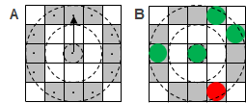

We calculated the univariate pair correlation functions, g11(r), g22(r) and the bivariate pair correlation function g12(r).We characterized each g(r) curve by a single value. For g11(r) and g22(r) we used the width at Δg/2 where Δg/2 is the difference between minimum and maximum of g(r) (fig. S1 H). For g12(r) we used the same method but with the distance to the nearest curve intersection as the depletion distance (fig S1 I). With these three single value data sets we created three maps (fig. S2 A-C).

Table S2A: random variables for surrogate model 1, before training.

|  |  |  |  |  |  |
| --- | --- | --- | --- | --- | --- |
| Type | Name | Description | Distribution | Distribution parameters | Unit |
| Random  variables | t | time | $$P(t)∼Uniform(lower, upper)$$ | $$lower=0,upper=100$$ | *sec* |
| κ | Membrane rigidity |  |  | *KT*nm2* |
|  |  | Depletion range between TCR and CD45 | $${P(dep}_{}^{KS})∼Normal(μ,σ)$$ | $${μ=b}_{dep}^{KS}+{at}_{dep}^{KS}⋅t+{aκ}_{dep}^{KS}⋅κ$$, $σ=20$ | *nm* |
| $$b_{dep}^{KS}$$ | Surface intercept | $${P(b}_{dep}^{KS})∼Normal(μ,σ)$$ | $$μ=0,σ=50$$ | *nm* |
| $${at}_{dep}^{KS}$$ | Slope for t | $${P(at}_{dep}^{KS})∼Normal(μ,σ)$$ | $$μ=10,σ=3$$ | *nm/sec* |
| $${aκ}_{dep}^{KS}$$ | Slope for k | $${P(aκ}_{dep}^{KS})∼Normal(μ,σ)$$ | $$μ=0,σ=1$$ | *1/(nm*KT)* |
| $${Noise}_{dep}^{KS}$$ | Uncertainty in ${dep}_{}^{KS}$ | $${P(Noise}_{dep}^{KS})∼HalfNormal(μ,σ)$$ | $$σ=20$$ | *nm* |

able 2B: random variable for surrogate model 2, after training.

|  |  |  |  |  |  |
| --- | --- | --- | --- | --- | --- |
| Type | Name | Description | Distribution | Distribution parameters | Unit |
| Random  variables | t | time | $$P(t)∼Uniform(lower, upper)$$ | $$lower=0,upper=100$$ | *sec* |
| κ | Membrane rigidity |  |  | *KT*nm2* |
|  |  | Depletion range between TCR and CD45 | $${P(dep}_{}^{KS})∼Normal(μ,σ)$$ | $${μ=b}_{dep}^{KS}+{at}_{dep}^{KS}⋅t+{aκ}_{dep}^{KS}⋅κ$$, $σ=20$ | *nm* |
| $$b_{dep}^{KS}$$ | Surface intercept | $${P(b}_{dep}^{KS})∼Normal(μ,σ)$$ | $$μ=99.2,σ=2.7$$ | *nm* |
| $${at}_{dep}^{KS}$$ | Slope for t | $${P(at}_{dep}^{KS})∼Normal(μ,σ)$$ | $$μ=0.28,σ=0.38$$ | *nm/sec* |
| $${aκ}_{dep}^{KS}$$ | Slope for k | $${P(aκ}_{dep}^{KS})∼Normal(μ,σ)$$ | $$μ=0.29,σ=0.39$$ | *1/(nm*KT)* |
| $${Noise}_{dep}^{KS}$$ | Uncertainty in ${dep}_{}^{KS}$ | $${P(Noise}_{dep}^{KS})∼HalfNormal(μ,σ)$$ | $$σ=21.8$$ | *nm* |

Fig. S2 - surrogate model (heatmap before after, maybe PGM topology)

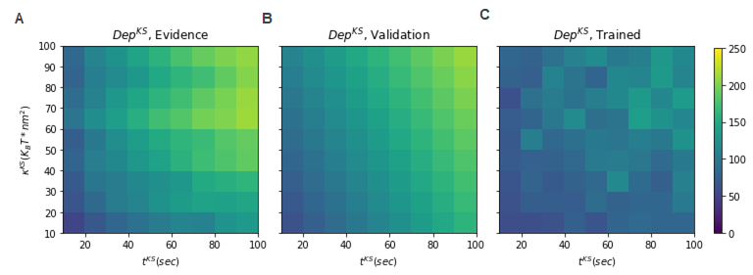

**Fig. S2. Getting a single value that characterizes the depletion range between TCR and CD45.** S2A) Heatmap of the evidence for the depletion distance between TCR and CD45. S2B) Heatmap used for validation of the and equations and random variables that we chose. S2C) Heatmap of the fitted model after running the PyMC3 package with the validated equations and random variables.

### 

### Model 2

Input model

**Model configuration.** The membrane is represented as a two-dimensional grid of 200 x 200 squares of 10 nm x 10 nm each. The free parameters and input variables of the model are described in Table S3. At the center of the array there is a CD45 molecule (activating location). All Lck molecules start their path at the center of the array as an active Lck. As the Lck* molecules diffuse away from the center with a diffusion coefficient DLck it is spontaneously deactivated with probability Poff at every iteration.

**Model simulation.** A typical simulation runs for 1000 iterations. To simulate Brownian diffusion of each molecule along the membrane, we sample a molecular step $r$ in a random direction (uniformly sampled between $0$ and $2π$ radians), and with a magnitude that is the absolute value of a normally distributed scalar with mean 0.0 and standard-deviation ; *D* is the diffusion coefficient in units of ${μm}^{2}{⋅s}^{-1}$. Therefore we can treat the propagation of the simulation as propagation in time with time step = $Δt$. In all simulations, we used $Δt=0.01 sec$. We used periodic boundary conditions (molecules that exit at one side enter on the other side). At every iteration all the molecules ‘jump’ to a new location with no limiting conditions.

### **Fig. S3** –Model 2 – Lck activation (LA) – Physical model + MC simulations

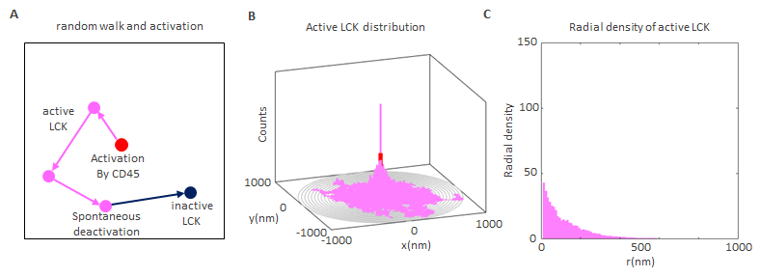

**Fig. S3. Lck activation as a result of an interaction with CD45**. S3A. The red point marks the location of a CD45 molecule. All Lck’s paths begin at an active state at the CD45 location. As they propagate in a two dimensional random walk they are being spontaneously deactivated with a probability Poff at every step. S3B. The magenta paths mark the locations of active Lck and the heights of the bars mark how many times active Lck molecules passed through this location (bin) during the simulation. S3C. Radial distribution of the locations of active Lck. The radial distribution is calculated as the sum over angles of the active Lck around the location of CD45 (gray rings in B). The radial distribution behaves as an exponential decay function and depends on the DLck and PoffLck*.

Table S3: Free parameters of Model 2

|  |  |  |  |  |
| --- | --- | --- | --- | --- |
| **Name** | **Description** | **Default value** | **Units** | **References** |
| Array size | size width x size length. | 2000x2000 | $$nm$$ | - |
| a | Area unit that divides the array to square units that has approximately the lateral size of a molecule. | 10 | $$nm$$ | WL,  InterCells |
| Δt | Iteration length. | 0.01 | $$sec$$ | InterCells |
| Niter | Number of iterations | 1000 | $$-$$ | InterCells |
| NLck | Total number of TCR molecules. | 1000 | $$-$$ | - |
| DLck | Diffusion coefficient of TCR molecules. | 10,000 | $$nm^{2}/sec$$ | WL |
| PoffLck | Probability of Lck deativation per one iteration | 0.01 | $$\sec^{-1}$$ | - |

#### 

#### Surrogate model:

To learn a surrogate model for Model 2, we first mapped its outputs for different input parameter values (Fig. S3). We created a probabilistic graphical model {REF} that describes statistical relations among its variables in parameterized form (Fig. XXX; Table S4); and then, we fitted the probabilistic graphical model to recapitulate the statistical relations between the model parameters and its values. We now explain each of these steps in detail.

**Parameter phase space mapping:** Specifically, we evaluated the model using 13 different values of diffusion coefficient, D and 11 values of Poff. $D={10}^{log10(logD)}$, where $logD$ is from -3 to 0 with intervals of 0.25. $Poff={10}^{log10(logPoff)}$, where $logPoff$ is from -5 to 0 with intervals of 0.5. For details see tables S4A,B.

Table S4A: random variables for surrogate model 2, before training. TBD

|  |  |  |  |  |  |
| --- | --- | --- | --- | --- | --- |
| Model 2 – Lck activation (LA) | | | | | |
| Type | Name | Description | Distribution | Distribution parameters | Units |
| Random variables |  | log10 of diffusion coefficient of Lck* |  |  |  |
|  | log10 of deactivation probability of LCK* |  |  |  |
|  | Sigmoid minimum |  |  |  |
|  | Sigmoid maximum |  |  |  |
|  | Poff sigmoid center |  |  | - |
|  | Poff sigmoid devisor |  |  | - |
|  | D sigmoid center |  |  | - |
|  | D sigmoid devisor |  |  | - |
|  | Used for sigmoid equation |  |  |  |
|  | Used for sigmoid equation | $$1/(1+e^{-x_{Poff}^{LA}})$$ |  |  |
| $$x_{D}^{LA}$$ | Used for sigmoid equation | $$D_{Lck*}^{LA}-{Dcen}_{λ,Lck*}^{LA}/{Ddev}_{λ,Lck*}^{LA}$$ |  |  |
| $${sig}_{D}^{LA}$$ | Used for sigmoid equation | $$1/(1+e^{-x_{D}^{LA}})$$ |  |  |
| $${Noise}_{λ,Lck*}^{LA}$$ | Noise\Uncertainty | $${Noise}_{λ,Lck*}^{LA}∼HalfNormal(μ,σ)$$ | $$σ=0.055$$ | $$1/nm$$ |
| $$λ_{Lck*}^{LA}$$ | Distribution width of Lck* | $${P(λ}_{Lck*}^{LA})∼Normal(μ,σ)$$ | μ= $\min_{λ,Lck*}^{LA}+{(max}_{λ,Lck*}^{LA}-\min_{λ,Lck*}^{LA}){sig}_{Poff}^{LA}⋅{sig}_{D}^{LA}$, $σ=0.2$ | $$1/nm$$ |

Table S4B: random variables for surrogate model 2, after training. TBD

|  |  |  |  |  |  |
| --- | --- | --- | --- | --- | --- |
| Model 2 – Lck activation (LA) | | | | | |
| Type | Name | Description | Distribution | Distribution parameters | Units |
| Random variables |  | log10 of diffusion coefficient of Lck* |  |  |  |
|  | log10 of deactivation probability of LCK* |  |  |  |
|  | Sigmoid minimum |  |  |  |
|  | Sigmoid maximum |  |  |  |
|  | Poff sigmoid center |  |  | - |
|  | Poff sigmoid devisor |  |  | - |
|  | D sigmoid center |  |  | - |
|  | D sigmoid devisor |  |  | - |
|  | Used for sigmoid equation |  |  |  |
|  | Used for sigmoid equation | $$1/(1+e^{-x_{Poff}^{LA}})$$ |  |  |
| $$x_{D}^{LA}$$ | Used for sigmoid equation | $$D_{Lck*}^{LA}-{Dcen}_{λ,Lck*}^{LA}/{Ddev}_{λ,Lck*}^{LA}$$ |  |  |
| $${sig}_{D}^{LA}$$ | Used for sigmoid equation | $$1/(1+e^{-x_{D}^{LA}})$$ |  |  |
| $${Noise}_{λ,Lck*}^{LA}$$ | Noise\Uncertainty | $${Noise}_{λ,Lck*}^{LA}∼HalfNormal(μ,σ)$$ | $$σ=0.055$$ | $$nm$$ |
| $$λ_{Lck*}^{LA}$$ | Distribution width of Lck* | $${P(λ}_{Lck*}^{LA})∼Normal(μ,σ)$$ | μ= $\min_{λ,Lck*}^{LA}+{(max}_{λ,Lck*}^{LA}-\min_{λ,Lck*}^{LA}){sig}_{Poff}^{LA}⋅{sig}_{D}^{LA}$, $σ=0.048$ | $$nm$$ |

### 

### Fig. S4.

#### Surrogate model:

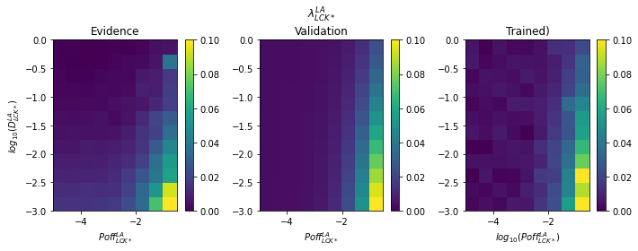

Fig. S4. A) untrained model: a heatmap that shows the decay coefficient of Lck* as a function of the diffusion coefficient, $D{}_{Lck}$, and the deactivation probability per iteration, $Poff{}_{Lck}$. B) Validation of the chosen equations and random variables for the trained model. C) Trained model calculated with the trained parameters.

### Model 3

**Input and output.** The model computes the spatial distribution of active (phosphorylated) TCR molecules (TCR*) on the T cell membrane from the spatial distributions of all TCR, CD45 molecules , and LCK* probability distribution that collectively regulates TCR activation.

**Model configuration.** The model configuration is defined by the spatial positions of the TCR and CD45 molecules on the membrane, represented using a 400 x 400 grid of 10 nm x 10 nm squares (Fig. S4A). Every grid square contains at most one molecule of each type. In this model the molecules are fixed. The probability distribution of Lck* around a single CD45 molecule is an exponential decay distribution with radial symmetry (Fig. S4B). The overall Lck* probability distribution around all the CD45 molecules is the sum of all the individual Lck* probability distributions (Fig. S4C).

**Model interactions.** The interactions in this model include the deactivation of TCR molecules by CD45 molecules, and the activation of TCR molecules by LCK* molecules. Both interactions depend on the intermolecular distances. The interaction parameters are described in Table XX.

**Model evaluation.** The probability of a TCR being phosphorylated is proportional the value of the Lck* probability distribution at the TCR location (Fig. S4D-E).

The TCR* probability distribution is computed

from the other three distributions: a TCR is phosphorylated if it is in the phosphorylation range (10nm) from a Lck*. a TCR is dephosphorylated if it is in the dephosphorylation range (10nm) from a CD45. In this model, TCR* value can be 1 or 0.

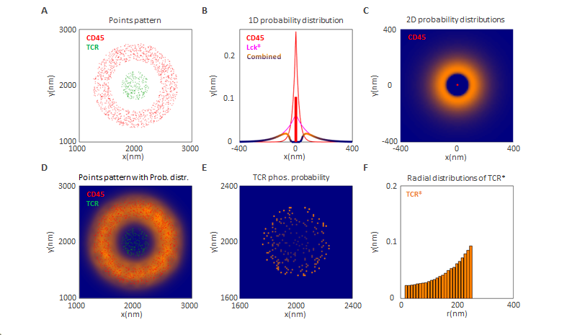

Figure S4A. Point patterns of TCR (green), and CD45 (red). We assume that the TCR molecules are arranged in a circle with radius r at the center of the array, the CD45 molecules are arranged in a concentric ring around the center. S4B. Probability distribution of active Lck (Lck*) (magenta shade) after being activated by CD45 (red point). The distribution has radial symmetry and a radial exponential decay. S4C. Sum of the Lck* probability distributions over all the CD45 molecules. S4D. Enlarged view of probability distribution in C relative to the TCR locations. S4E. multiplication of probability distribution in D by the locations of TCR (value at TCR locations = 1, otherwise = 0). S4F. Radial distribution histograms centered at (2000,2000) nm. Green - radial distribution of TCR locations. Parula gradient - TCR phosphorylation probability (not in scale). Orange - ratio of phosphorylation probability to TCR distribution (proportional to Lck* probability distribution) (not in scale..

Table xx: Free parameters of Model 3

|  |  |  |  |  |
| --- | --- | --- | --- | --- |
| Name | Description | Default value | Units | References |
| Array size | Two dimensional grid of squares | 4000x4000 | nm | - |
| a | Square size | 10 | nm |  |
| TCR distribution | A ring with inner radius, r1 and outer radius r2 with uniform distribution. | r1 = 0  r2 = 250 | nm | - |
| CD45 distribution | A ring with inner radius, r1 and outer radius r2 with uniform distribution. | r1 = 450  r2 = 750 | nm | - |
| Single Lck* distribution | Two dimensional exponential-decay probability distribution with radial symmetry around the location of a CD45. | λ = 0.01 | nm-1 | - |
| Total Lck* distribution |  |  |  |  |
| Interaction |  |  |  |  |
| Interaction |  |  |  |  |

### 

#### 

#### 

#### Surrogate model:

Description TBD - Random text: The configuration space is defined by four vectors, one for each molecular species. Each vector describes the mean molecular density per μm2 as a function of the distance from a shared center, using 200 x 0.01 μm bins, running from 0 μm to 2 μm (fig. S4 B). batch parameters

Table S6A: random variables for surrogate model 1, before training.

|  |  |  |  |  |  |
| --- | --- | --- | --- | --- | --- |
| Model 3 – pTCR (LA) | | | | | |
| Type | Name | Description | Distribution | Distribution parameters | Units |
| Random variables | $$D_{Lck*}^{LA}$$ | log10 of diffusion coefficient of Lck* |  |  |  |
|  | log10 of deactivation probability of LCK* |  |  |  |
|  | Sigmoid minimum |  |  | nm |
|  | Sigmoid maximum |  |  | nm |
|  | Poff sigmoid center |  |  | - |
|  | D sigmoid devisor |  |  | - |
|  | Poff sigmoid center |  |  | - |
|  | D sigmoid devisor |  |  | - |
|  | Used for sigmoid equation |  |  |  |
|  | Used for sigmoid equation | $$1/(1+e^{-x_{Poff}^{LA}})$$ |  |  |
| $$x_{D}^{LA}$$ | Used for sigmoid equation | $$D_{Lck*}^{LA}-{Dcen}_{w,Lck*}^{LA}/{Ddev}_{w,Lck*}^{LA}$$ |  |  |
| $${sig}_{D}^{LA}$$ | Used for sigmoid equation | $$1/(1+e^{-x_{D}^{LA}})$$ |  |  |
| $${Noise}_{w,Lck*}^{LA}$$ | Uncertainty in $w_{Lck*}^{LA}$ | $${Noise}_{w,Lck*}^{LA}∼HalfNormal(μ,σ)$$ | $$σ=50$$ | nm |
| $$w_{Lck*}^{LA}$$ | Distribution width of Lck* | $${P(w}_{Lck*}^{LA})∼Normal(μ,σ)$$ | μ= $\min_{w,Lck*}^{LA}+{(max}_{w,Lck*}^{LA}-\min_{w,Lck*}^{LA}){sig}_{Poff}^{LA}⋅{sig}_{D}^{LA}$, $σ=20$ | nm |

Table S6B: random variable for surrogate model 3, after training

|  |  |  |  |  |  |
| --- | --- | --- | --- | --- | --- |
| Model32 – Lck activation (LA) | | | | | |
| Type | Name | Description | Distribution | Distribution parameters | Units |
| Random variables | $$D_{Lck*}^{LA}$$ | log10 of diffusion coefficient of Lck* |  |  |  |
|  | log10 of deactivation probability of LCK* |  |  |  |
|  | Sigmoid minimum |  |  | nm |
|  | Sigmoid maximum |  |  | nm |
|  | Poff sigmoid center |  |  | - |
|  | D sigmoid devisor |  |  | - |
|  | Poff sigmoid center |  |  | - |
|  | D sigmoid devisor |  |  | - |
|  | Used for sigmoid equation |  |  |  |
|  | Used for sigmoid equation | $$1/(1+e^{-x_{Poff}^{LA}})$$ |  |  |
| $$x_{D}^{LA}$$ | Used for sigmoid equation | $$D_{Lck*}^{LA}-{Dcen}_{w,Lck*}^{LA}/{Ddev}_{w,Lck*}^{LA}$$ |  |  |
| $${sig}_{D}^{LA}$$ | Used for sigmoid equation | $$1/(1+e^{-x_{D}^{LA}})$$ |  |  |
| $${Noise}_{w,Lck*}^{LA}$$ | Uncertainty in $w_{Lck*}^{LA}$ | $${Noise}_{w,Lck*}^{LA}∼HalfNormal(μ,σ)$$ | $$σ=50$$ | nm |
| $$w_{Lck*}^{LA}$$ | Distribution width of Lck* | $${P(w}_{Lck*}^{LA})∼Normal(μ,σ)$$ | μ= $\min_{w,Lck*}^{LA}+{(max}_{w,Lck*}^{LA}-\min_{w,Lck*}^{LA}){sig}_{Poff}^{LA}⋅{sig}_{D}^{LA}$, $σ=20$ | nm |

Figure S6: surrogate model 3

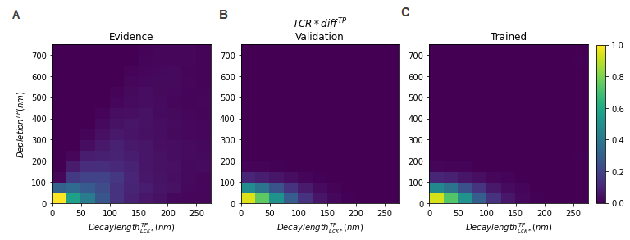

TBD

## Coupling

Description TBD

Table S7A (coupling variables depending on model variables)

|  |  |  |  |  |  |
| --- | --- | --- | --- | --- | --- |
| Model32 – Lck activation (LA) | | | | | |
| Type | Name | Description | Distribution | Distribution parameters | Units |
| Random variables |  |  |  |  |  |
|  |  |  |  |  |
|  |  |  |  |  |
|  |  |  |  |  |
|  |  |  |  |  |
|  |  |  |  |  |
|  |  |  |  |  |
|  |  |  |  |  |
|  |  |  |  |  |
|  |  |  |  |  |
|  |  |  |  |  |
|  |  |  |  |  |
|  |  |  |  |  |
|  |  |  |  |  |

Table S7B (model variables now depending on coupling variables)

|  |  |  |  |  |  |
| --- | --- | --- | --- | --- | --- |
| Model32 – Lck activation (LA) | | | | | |
| Type | Name | Description | Distribution | Distribution parameters | Units |
| Random variables |  |  |  |  |  |
|  |  |  |  |  |
|  |  |  |  |  |
|  |  |  |  |  |
|  |  |  |  |  |
|  |  |  |  |  |
|  |  |  |  |  |
|  |  |  |  |  |
|  |  |  |  |  |
|  |  |  |  |  |
|  |  |  |  |  |
|  |  |  |  |  |
|  |  |  |  |  |
|  |  |  |  |  |

Figure S7: topology of coupled PGM? (maybe only in main text)

Backpropagation